**INTRODUCTION**

This database focuses on 5 aspects of a typical VTU result system:

* Student
* Department
* Internal Marks
* External Marks
* Subjects

This Application is intended for college authorities, professors, HODs, program coordinators etc. It is useful for anyone interested in learning about the exam performance of their respective purposes for analysis.

After choosing any of the options mentioned above, the intended users can select & view details such as:

* Students and their details like USN, name, department they belong to.
* Overview of Each Department, the department number and its strength
* The internal marks of any student for each internal conducted.
* The external marks obtained and the resulting grade.
* The list of available subjects and their codes.
* Analysis of pass/fail percentage for any given subject.

**SYSTEM REQUIREMENTS**

**Hardware and Software Requirements**

* **Processors:** Intel Pentium Dual Core or higher
* **Processor Speed:** 1.4 GHz
* **RAM:** 2 GB
* **Storage:** 500Mb
* **Operating System:** Windows/Linux
* XAMPP/LAMPP, Apache and MySQL required to Stimulate DBMS Environment
* **Web Browser:** Google Chrome/Edge

## Chapter 3

**Section 3.1 Schema**

**DESIGN**

**STUDENT**

|  |  |  |  |  |
| --- | --- | --- | --- | --- |
| **NAME** | **USN** | **BATCH** | **SEM** | **DNO.** |

**EXTERNAL MARKS**

|  |  |  |  |  |  |  |
| --- | --- | --- | --- | --- | --- | --- |
| **USN** | **SEM** | **SUBCODE** | **EXTERNAL** | **TOTAL** | **RESULT** | **GRADE** |

**INTERNAL MARKS**

|  |  |  |  |  |  |  |
| --- | --- | --- | --- | --- | --- | --- |
| **SUBCODE** | **USN** | **SEM** | **IAT1** | **IAT2** | **IAT3** | **FINAL IAT** |

**DEPARTMENTS**

|  |  |  |  |
| --- | --- | --- | --- |
| **DNAME** | **DNO.** | **HOD** | **STRENGTH** |

**SUBJECTS**

|  |  |  |  |
| --- | --- | --- | --- |
| **NAME** | **SUBCODE** | **CREDITS** | **DNO** |

**Section 3.2 ER Diagram**

**i**

Obtains

Obtains

Study in

for

Subjects

for

External

Internals

Dept

Student

**Chapter 4**

**Section 4.1**

**Home**

**Page**

**Section 4.1.1 HTML**

**<!DOCTYPE html>**

<html>

<head>

<link rel="stylesheet" href="home.css">

</head>

<body>

<h1><font size="10">Result Management System</font></h1>

<p><font size="5"><b>Select an option from below</b></font</p>

<p><a href="./students/students.html" class="button button1">Students</a></p>

<p><a href="./department/departments.html" class="button button1">Departments</a></p>

<p><a href="./ia/internal_marks.html" class="button button1">Internal Marks</a></p>

<p><a href="./ea/external_marks.html" class="button button1">External Marks</a></p>

<p><a href="./subjects/subjects.html" class="button button1">Subjects</a></p>

<p><a href="./analysis/analysis.html" class="button button1">Analysis</a></p>

</body>

</html>

**Section 4.2**

**Students**

### HTML

<html><head>

</head><body>

<h1>Students<h1>

<button onclick="location.href = window.location.href='/students/students_show.php';" class="button button1">Show Table</button>

<h2>Insert Record</h2

<div class="container">

<form action="students_insert.php" method="post">

<label for="fname">Name</label>

<input type="text" id="fname" name="Name">

<label for="lname">USN</label>

<input type="text" id="usn" name="USN">

<label for="lname">Current Semester </label>

<input type="text" id="cur" name="Cur_sem">

<label for="batch">Batch</label>

<input type="text" id="batch" name="Batch">

<label for="batch">Department Number</label>

<input type="text" id="deptno" name="Dno">

<input type="submit" value="Submit">

</form></div>

<h2>Update Record</h2>

<div class="container">

<form action="student_update.php" method="post">

<label for="lname">Enter USN of record to be updated</label>

<input type="text" id="u" name="usnc">

<h3>Enter Update Details</h3>

<label for="fname">Name</label>

<input type="text" id="fname" name="name">

<label for="lname">USN</label>

<input type="text" id="u" name="usn">

<label for="lname">Current Semester</label>

<input type="text" id="cur_semester" name="cur_sem">

<label for="batch">Batch</label>

<input type="text" id="batcH" name="batch">

<label for="batch">Department Number</label>

<input type="text" id="deptno" name="dno">

<input type="submit" value="Submit">

</form></div>

<h2>Delete Record</h2>

<div class="container">

<form action="students_del.php" method="post">

<label for="lname">Enter USN of record to be Deleted</label>

<input type="text" id="usn" name="usn">

<input type="submit" value="Submit">

</form>

</div>

</body>

</htmL>

### Section 4.2.2

**PHP**

**Students Show**

<?php

$servername = "localhost";

$username = "pavan";

$password = "password";

$dbname = "DBMS_PROJECT";

// Create connection

$conn = new mysqli($servername, $username, $password, $dbname);

// Check connection

if ($conn->connect_error) {

die("Connection failed: " . $conn->connect_error);}

echo '<html><head><br>Students Table :<br><style>table, th, td {border: 1px solid black;}</style></head><body><table><tr>';

$sql = "CALL disp_student()";

$result = $conn->query($sql);

if ($result->num_rows > 0) {

// output data of each row

// $fieldinfo=mysqli_fetch_fields($result);

$val=array();

while($fieldinfo=mysqli_fetch_field($result)){

$val[]=$fieldinfo->name;

echo '<th>'.$fieldinfo->name.'</th>' ; }

echo '</tr>';

while($row = $result->fetch_assoc()) {

echo '<tr> ';

foreach ($val as $valu){

echo '<td>'.$row[$valu].'</td>';}

echo '</tr>'; }

echo '</table>';}

echo '</body></html>';

$conn->close();

?>

**Students Insert**

<?php

$servername = "localhost";

$username = "pavan";

$password = "password";

$dbname = "DBMS_PROJECT";

// Create connection

$conn = new mysqli($servername, $username, $password, $dbname);

// Check connection

if ($conn->connect_error) {

die("Connection failed: " . $conn->connect_error);

}

$sql = "INSERT INTO Students values(".$_POST["USN"].",'".$_POST["Name"]."',".$_POST["Cur_sem"].",".$_POST["Dno"].",'".$_POST["Batch"]."')";

if ($conn->query($sql) === TRUE) {

echo "New record created successfully";

} else {

echo "Error: " . $sql . "<br>" . $conn->error;}

$conn->close();

?>

**Students Update**

<?php

$servername = "localhost";

$username = "pavan";

$password = "password";

$dbname = "DBMS_PROJECT";

// Create connection

$conn = new mysqli($servername, $username, $password, $dbname);

// Check connection

if ($conn->connect_error) {

die("Connection failed: " . $conn->connect_error);

}

$i=0;

$arr=array("usn","name","cur_sem","batch","dno");

while($i<5){

if($_POST[$arr[$i]]!=NULL){

if($arr[$i]=="name"||$arr[$i]=="batch")

$_POST[$arr[$i]]="'".$_POST[$arr[$i]]."'";

//echo "UPDATE Students SET ".$arr[$i]."=".$_POST[$arr[$i]]." WHERE usn=".$_POST["usnc"]."<br>";

$sql = "UPDATE Students SET ".$arr[$i]."=".$_POST[$arr[$i]]." WHERE usn=".$_POST["usnc"];

if ($conn->query($sql) === FALSE) {

echo $conn->error."<br>";

break;

}

else

echo $arr[$i]." is updated successfully.<br>";

}

$i=$i+1;

}

**Students Delete**

<?php

$servername = "localhost";

$username = "pavan";

$password = "password";

$dbname = "DBMS_PROJECT";

// Create connection

$conn = new mysqli($servername, $username, $password, $dbname);

// Check connection

if ($conn->connect_error) {

die("Connection failed: " . $conn->connect_error);

}

$sql = "DELETE from Students WHERE usn=".$_POST["usn"];

if ($conn->query($sql) === FALSE)

echo $conn->error."<br>";

else

echo "sucessfully deleted record";

$conn->close();

?>

**Section 4.3**

**DepartmentSection 4.3.1**

### HTML

<!DOCTYPE html>

<html>

<head>

<meta name="viewport" content="width=device-width, initial-scale=1">

</head>

<body>

<h1>Departments<h1>

<p> </p>

<button onclick="location.href = window.location.href='/department/department_show.php';" class="button button1">Show Table</button>

<h2>Insert Record</h2>

<div class="container">

<form action="/department/department_insert.php" method="post">

<label for="deptname">Department Name</label>

<input type="text" id="deptname" name="Dname">

<label for="deptno">Department Number</label>

<input type="text" id="deptno" name="Dno">

<label for="batch">Head of Department</label>

<input type="text" id="batch" name="HOD">

<input type="submit" value="Submit">

</form>

</div>

</body>

</html>

## PHP

## Insert

## <?php

## $servername = "localhost";

## $username = "pavan";

## $password = "password";

## $dbname = "DBMS_PROJECT";

## $conn = new mysqli($servername, $username, $password, $dbname);

## if ($conn->connect_error) {

## die("Connection failed: " . $conn->connect_error);}

## $sql = "INSERT INTO Departments values('".$_POST["Dname"]."',".$_POST["Dno"].",'".$_POST["HOD"]."')";

## if ($conn->query($sql) === TRUE) {

## echo "New record created successfully";

## } else {

## echo "Error: " . $sql . "<br>" . $conn->error;}

## $conn->close();

## ?>

## Delete

## <?php

## $servername = "localhost";

## $username = "pavan";

## $password = "password";

## $dbname = "DBMS_PROJECT";

## $conn = new mysqli($servername, $username, $password, $dbname);

## // Check connection

## if ($conn->connect_error) {

## die("Connection failed: " . $conn->connect_error);}

## $sql = "DELETE from Departments WHERE dno=".$_POST["dno"];

## if ($conn->query($sql) === FALSE)

## echo $conn->error."<br>";

## else

## echo "sucessfully deleted record";

## $conn->close();

## ?>

## Section 4.4

**Internal Marks**

### HTML

<!DOCTYPE html>

<html>

<head>

<meta name="viewport" content="width=device-width, initial-scale=1">

</head>

<body>

<h1>Internal Marks</h1>

<p> </p>

<button onclick="location.href = window.location.href='/ia/ia_show.php';" class="button button1">Show Table</button>

<h2>Insert Record</h2>

<div class="container">

<form action="ia_insert.php" method="post">

<label for="fname">Subject Code</label>

<input type="text" id="fname" name="subcode">

<label for="lname">USN</label>

<input type="text" id="usn" name="usn">

<label for="batch">Semester</label>

<input type="text" id="batch" name="sem">

<label for="batch">IAT1</label>

<input type="text" id="deptno" name="ia1">

<label for="batch">IAT2</label>

<input type="text" id="deptno" name="ia2">

<label for="batch">IAT3</label>

<input type="text" id="deptno" name="ia3">

<input type="submit" value="Submit">

</form>

</div>

<h2>Update Record</h2>

<div class="container">

<form action="ia_update.php" method="post">

<label for="lname">Enter USN of record to be updated</label>

<input type="text" id="usn" name="usnc"

<label for="lname">Enter sem of record to be updated</label>

<input type="text" id="us" name="semc">

<label for="lname">Enter subcode of record to be updated</label>

<input type="text" id="u" name="subcodec">

<h3>Enter Update Details</h3>

<label for="fname">Subject Code</label>

<input type="text" id="fname" name="subcode">

<label for="lname">USN</label>

<input type="text" id="usn" name="usn">

<label for="batch">Semester</label>

<input type="text" id="batch" name="sem">

<label for="batch">IAT1</label>

</div></body></html>

### Section 4.4.2

**PHP**

**Insert**

<?php

$servername = "localhost";

$username = "pavan";

$password = "password";

$dbname = "DBMS_PROJECT";

// Create connection

$conn = new mysqli($servername, $username, $password, $dbname);

// Check connection

if ($conn->connect_error) {

die("Connection failed: " . $conn->connect_error);

}

$sql = "INSERT INTO Internal_Marks(usn,sem,subcode,iat1,iat2,iat3) values(".$_POST["usn"].",".$_POST["sem"].",'".$_POST["subcode"]."',".$_POST["ia1"].",".$_POST["ia2"].",".$_POST["ia3"].")";

if ($conn->query($sql) === TRUE) {

$conn->query("CALL update_final(".$_POST["usn"].",".$_POST["sem"].",'".$_POST["subcode"]."')");

if ($conn->query("CALL update_final(".$_POST["usn"].",".$_POST["sem"].",'".$_POST["subcode"]."')") === TRUE)

echo "New record created successfully";

else

echo $conn->error;} else {

echo "Error: " . $sql . "<br>" . $conn->error;}

$conn->close();

?>

**Update**

<?php

$servername = "localhost";

$username = "pavan";

$password = "password";

$dbname = "DBMS_PROJECT";

// Create connection

$conn = new mysqli($servername, $username, $password, $dbname);

if ($conn->connect_error) {

die("Connection failed: " . $conn->connect_error);}

$arr=array("usn","subcode","sem","iat1","iat2","iat3","final_iat");

while($i<8){

if($_POST[$arr[$i]]!=NULL){

if($arr[$i]=="subcode")

$_POST[$arr[$i]]="'".$_POST[$arr[$i]]."'";

$sql = "UPDATE Internal_Marks SET ".$arr[$i]."=".$_POST[$arr[$i]]." WHERE subcode='".$_POST["subcodec"]."' and sem=".$_POST["semc"]." and usn=".$_POST["usnc"];

if ($conn->query($sql) === FALSE) {

echo $conn->error."<br>";

break;}

else

echo $arr[$i]." is updated successfully.<br>";}

$i=$i+1}

$conn->close();

?>

**Section 4.5**

**External Marks**

### HTML

### <html>

### <body>

### <h1>External Marks<h1>

### Table</button>

### <h2>Insert Record</h2>

### <div class="container">

### <form action="/ea_insert.php" method="post">

### <label for="fname">Subject Code</label>

### <input type="text" id="fname" name="subcode">

### <label for="lname">USN</label>

### <input type="text" id="usn" name="usn">

### <label for="batch">Semester</label>

### <input type="text" id="batch" name="sem">

### <label for="batch">External Marks</label>

### <input type="text" id="deptno" name="ea">

### <label for="batch">Total</label>

### <input type="text" id="deptno" name="total">

### <label for="batch">Result</label>

### <input type="text" id="deptno" name="result">

### <label for="batch">Grade</label>

### <input type="text" id="deptno" name="grade">

### <h2>Update Record</h2>

### <div class="container">

### <form action="/ea/ea_update.php" method="post">

### <label for="lname">Enter USN of record to be updated</label>

### <input type="text" id="usn" name="usnc">

### <label for="lname">Enter sem of record to be updated</label>

### <input type="text" id="us" name="semc">

### <label for="lname">Enter subcode of record to be updated</label>

### <input type="text" id="u" name="subcodec">

### <h3>Enter Update Details</h3>

### <label for="fname">Subject Code</label>

### <input type="text" id="fname" name="subcode">

### <label for="lname">USN</label>

### <input type="text" id="usn" name="usn"

### <label for="batch">Semester</label>

### <input type="text" id="batch" name="sem">

### <label for="batch">External Marks</label>

### <input type="text" id="deptno" name="external">

### <label for="batch">Total</label>

### <input type="text" id="deptno" name="result">

### <input type="submit" value="Submit">

### </form>

### </div></body></html>

### PHP

**Display**

<?php

$servername = "localhost";

$username = "pavan";

$password = "password";

$dbname = "DBMS_PROJECT";

// Create connection

$conn = new mysqli($servername, $username, $password, $dbname);

// Check connection

if ($conn->connect_error) {

die("Connection failed: " . $conn->connect_error);}

echo '<html><head><style>table, th, td {border: 1px solid black;}</style></head><body>';

echo '<br><br>External Marks :<br><table><tr>';

$sql = "CALL disp_ea_marks()";

$result = $conn->query($sql);

if ($result->num_rows > 0) {

// output data of each row

// $fieldinfo=mysqli_fetch_fields($result);

$val=array();

while($fieldinfo=mysqli_fetch_field($result)){

$val[]=$fieldinfo->name;

echo '<th>'.$fieldinfo->name.'</th>' ; }

echo '</tr>';

while($row = $result->fetch_assoc()) {

echo '<tr> ';

foreach ($val as $valu){

echo '<td>'.$row[$valu].'</td>'}

echo '</tr>' }

echo '</table>'}

echo '</body></html>';

$conn->close();

?>

**Delete Record**

<?php

$servername = "localhost";

$username = "pavan";

$password = "password";

$dbname = "DBMS_PROJECT";

// Create connection

$conn = new mysqli($servername, $username, $password, $dbname);

// Check connection

if ($conn->connect_error) {

die("Connection failed: " . $conn->connect_error);

}

$sql = "DELETE from External_Marks WHERE usn=".$_POST["usn"]." and sem=".$_POST["sem"]." and subcode='".$_POST["subcode"]."'";

if ($conn->query($sql) === FALSE)

echo $conn->error."<br>";

else

echo "sucessfully deleted record";

$conn->close();

?>

**Section 4.6 Subjects**

### HTML

<html>

<head>

<meta name="viewport" content="width=device-width, initial-scale=1">

</head><body>

<h1>Subjects<h1>

<button onclick="location.href = window.location.href='/subjects/subjects_show.php';" class="button button1">Show Table</button>

<h2>Insert Record</h2>

<div class="container">

<form action="/subjects_insert.php" method="post">

<label for="fname">Subject Name</label>

<input type="text" id="fname" name="subname">

<label for="lname">Subject Code</label>

<input type="text" id="usn" name="subcode">

<label for="batch">Credits</label>

<input type="text" id="batch" name="credits">

<label for="batch">Department Number</label>

<input type="text" id="deptno" name="Dno">

<input type="submit" value="Submit">

</form>

</div>

<h2>Update Record</h2>

<div class="container">

<form action="/subjects/update_subjects.php" method="post">

<label for="lname">Enter Subject Code of record to be updated</label>

<input type="text" id="usn" name="subcodec">

<h3>Enter Update Details</h3>

<label for="fname">Subject Name</label>

<input type="text" id="fname" name="name">

<label for="lname">Subject Code</label>

<input type="text" id="usn" name="subcode">

<label for="batch">Credits</label>

<input type="text" id="batch" name="credits">

<label for="batch">Subject Type</label>

<input type="text" id="deptno" name="dno">

<input type="submit" value="Submit">

</form>

</div>

<h2>Delete Record</h2>

<div class="container">

<form action="/subjects/subjects_del.php" method="post">

<label for="lname">Enter Subject Code of record to be deleted</label>

<input type="text" id="subcode" name="subcode">

<input type="submit" value="Submit">

</form>

</div>

</body>

</html>

### PHP

### Subjects Show

### <?php

### $servername = "localhost";

### $username = "pavan";

### $password = "password";

### $dbname = "DBMS_PROJECT";

### // Create connection

### $conn = new mysqli($servername, $username, $password, $dbname);

### // Check connection

### if ($conn->connect_error) {

### die("Connection failed: " . $conn->connect_error);

### }

### echo '<html><head><style>table, th, td {border: 1px solid black;}</style></head><body>';

### echo '<br><br>Subjects Table:<br><table><tr>';

### $sql = "CALL disp_subs()";

### $result = $conn->query($sql);

### if ($result->num_rows > 0) {

### // output data of each row

### // $fieldinfo=mysqli_fetch_fields($result);

### $val=array();

### while($fieldinfo=mysqli_fetch_field($result)){

### $val[]=$fieldinfo->name;

### echo '<th>'.$fieldinfo->name.'</th>' ;

### }

### echo '</tr>';

### while($row = $result->fetch_assoc()) {

### echo '<tr> ';

### foreach ($val as $valu){

### echo '<td>'.$row[$valu].'</td>';

### }

### echo '</tr>';

### }

### echo '</table>';

### }

### echo '</body></html>';

### $conn->close();

### ?>

### Subjects Insert

### <?php

### $servername = "localhost";

### $username = "pavan";

### $password = "password";

### $dbname = "DBMS_PROJECT";

### // Create connection

### $conn = new mysqli($servername, $username, $password, $dbname);

### // Check connection

### if ($conn->connect_error) {

### die("Connection failed: " . $conn->connect_error);

### }

### $sql = "INSERT INTO Subjects values(".$_POST["subcode"].",'".$_POST["subname"]."',".$_POST["credits"].",".$_POST["Dno"].")";

### if ($conn->query($sql) === TRUE) {

### echo "New record created successfully";

### } else {

### echo "Error: " . $sql . "<br>" . $conn->error;

### }

### $conn->close();

### ?>

### Subjects Delete

### <?php

### $servername = "localhost";

### $username = "pavan";

### $password = "password";

### $dbname = "DBMS_PROJECT";

### // Create connection

### $conn = new mysqli($servername, $username, $password, $dbname);

### // Check connection

### if ($conn->connect_error) {

### die("Connection failed: " . $conn->connect_error);}

### $sql = "DELETE from Subjects WHERE subcode="."'".$_POST["subcode"]."'";

### if ($conn->query($sql) === FALSE)

### echo $conn->error."<br>";

### else

### echo "sucessfully deleted record";

### $conn->close();

### ?>

**Section 4.7 Analysis**

### HTML

<!DOCTYPE html>

<html><head>

<meta name="viewport" content="width=device-width, initial-scale=1">

</head>

<body>

<h1>Result Analysis<h1>

<h2>Enter Details</h2>

<div class="container">

<form action="analysis.php" method="post">

<label for="lname">Subject Code</label>

<input type="text" id="subcode" name="subcode">

<input type="submit" value="Submit">

</form>

</div></body></html>

**PHP**

## <?php

## $servername = "localhost";

## $username = "pavan";

## $password = "password";

## $dbname = "DBMS_PROJECT";

## // Create connection

## $conn = new mysqli($servername, $username, $password, $dbname);

## // Check connection

## if ($conn->connect_error) {

## die("Connection failed: " . $conn->connect_error);}

## echo '<html><head><h1>Result Analysis</h1></head><body>';

## $sql = "SELECT COUNT(*) as fail from External_Marks where result='F' and subcode='".$_POST["subcode"]."'";

## $result = $conn->query($sql);

## if ($result->num_rows > 0) {

## $row=$result->fetch_assoc();

## $fail=$row["fail"];

## echo "Number of students failed:$fail<br>";}

## echo "<p> </p>";

## $sql = "SELECT COUNT(*) as pass from External_Marks where result='P' and subcode='".$_POST["subcode"]."'";

## $result = $conn->query($sql);

## if ($result->num_rows > 0) {

## $row=$result->fetch_assoc();

## $pass=$row["pass"];

## echo "Number of students passed:$pass<br>";

## }

## $conn->close();

## ?>

## Pie Chart

## <div id="piechart"></div>

## <script type="text/javascript" src="https://www.gstatic.com/charts/loader.js"></script>

## <script type="text/javascript">

## // Load google charts

## google.charts.load('current', {'packages':['corechart']});

## google.charts.setOnLoadCallback(drawChart);

## function drawChart() {

## var data = google.visualization.arrayToDataTable([

## ['Pass/Fail', 'Number_of_students'],

## ['PASS', parseInt('<?php echo $pass; ?>')],

## ['FAIL', parseInt('<?php echo $fail; ?>')],

## ]);

## // Optional; add a title and set the width and height of the chart

## var options = {'title':'Pass/Fail percentage', 'width':550, 'height':400};

## // Display the chart inside the <div> element with id="piechart"

## var chart = new google.visualization.PieChart(document.getElementById('piechart'));

## chart.draw(data, options);

## }

## </script>

## </body></html>

**TRIGGERS AND PROCEDURES**

**Trigger to set department strength to zero upon creation and increment or decrement strength based on any record inserted or deleted respectively.**

create trigger str_before_dept_trig before insert on Departments for each row begin set NEW.strength=0;

create trigger str_afterins_student_trig after insert on Students for each row update Departments set strength=strength+1 where Departments.dno=NEW.dno;

create trigger str_afterdel_student_trig after delete on Students for each row update Departments set strength=strength-1 where Departments.dno=OLD.dno;

**Trigger to automatically calculate the grade and result of a student’s marks based on input.**

create trigger trig_before_insert on External_Marks for each row begin if(NEW.total > 80) then set NEW.grade='A'; set NEW.result='PASS'; elseif(NEW.total > 70) then set NEW.grade='B';set NEW.result='PASS'; elseif(NEW.total > 60) then set NEW.grade='C';set NEW.result='FAIL'; else set NEW.grade='D';set NEW.result='FAIL'; END if; End

**Procedures to display all table records**

create procedure disp_student() begin select * from Students; end$$

create procedure disp_dept() begin select * from Departments; end$$

create procedure disp_subs() begin select * from Subjects; end$$

create procedure disp_ia_marks() begin select * from Internal_Marks; end$$

create procedure disp_ea_marks() begin select * from External_Marks; end$$

create procedure update_final(IN a int ,IN b int, IN c varchar(30))

**Procedure to calculate final IAT marks as an average of all three IATs.**

create procedure update_final(IN a int ,IN b int, IN c varchar(30))

begin

update Internal_Marks set final_iat=(iat1+iat2+iat3)/3 where subcode=c and usn=a and sem=b;

end

## Chapter 5

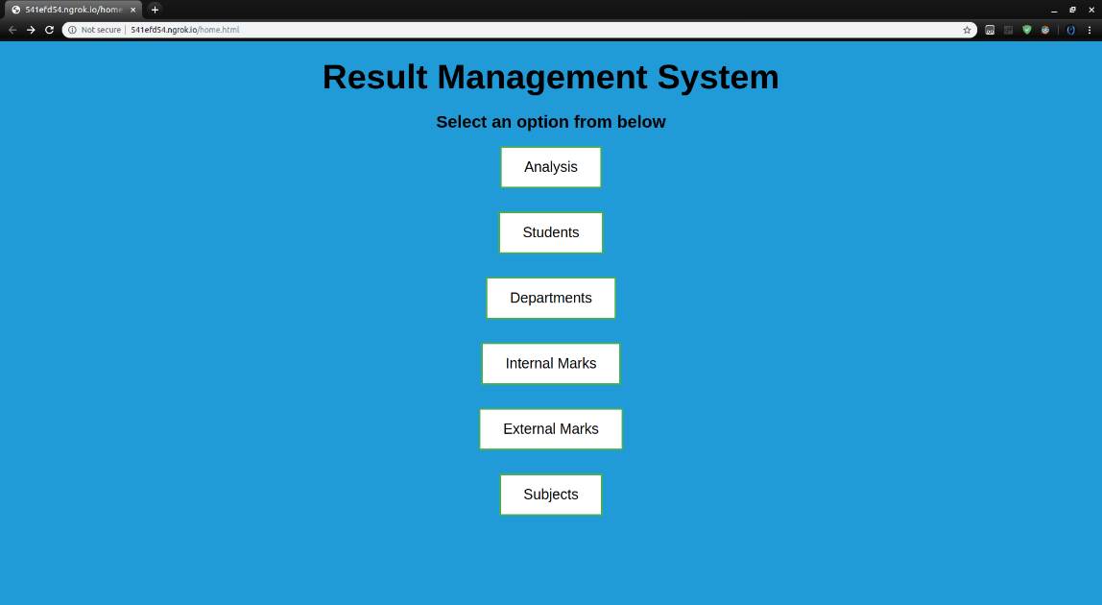

**DISCUSSION & SCREENSHOTS**

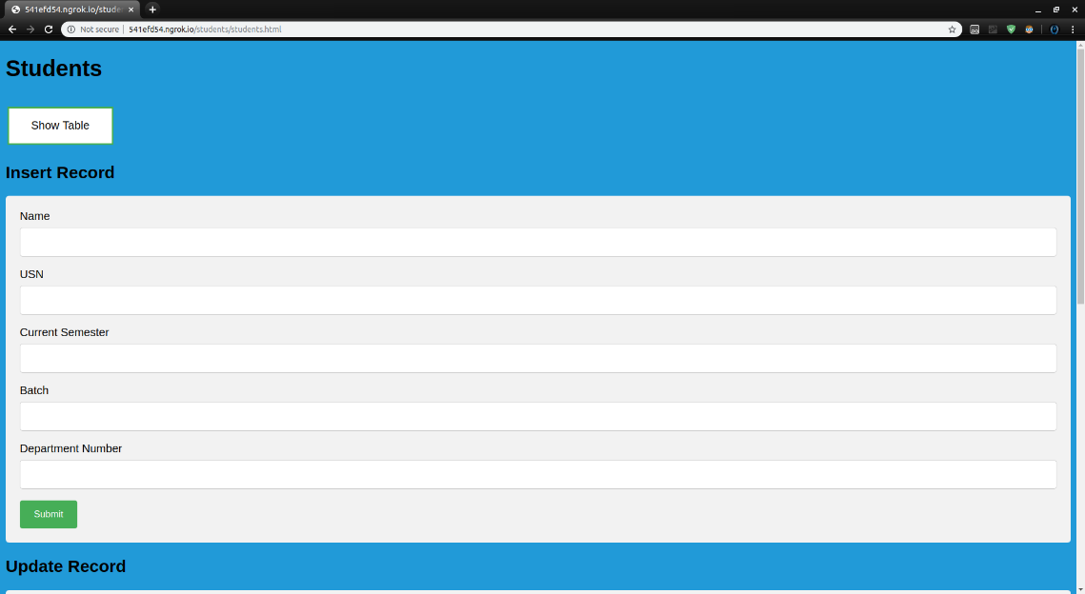

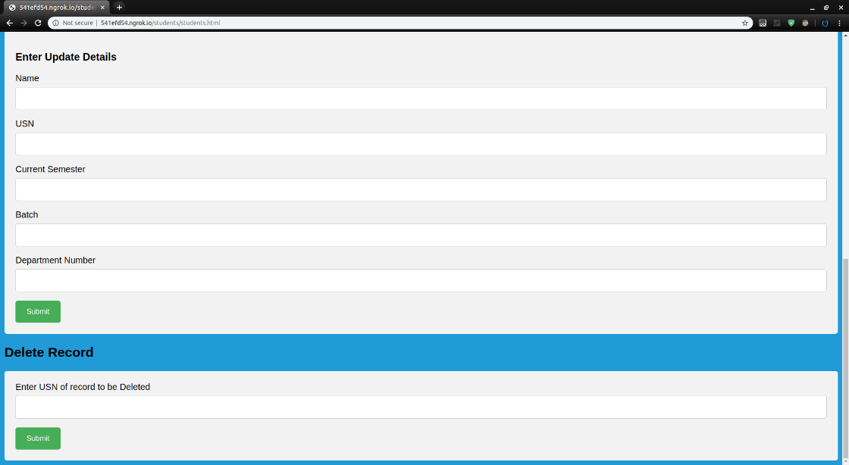

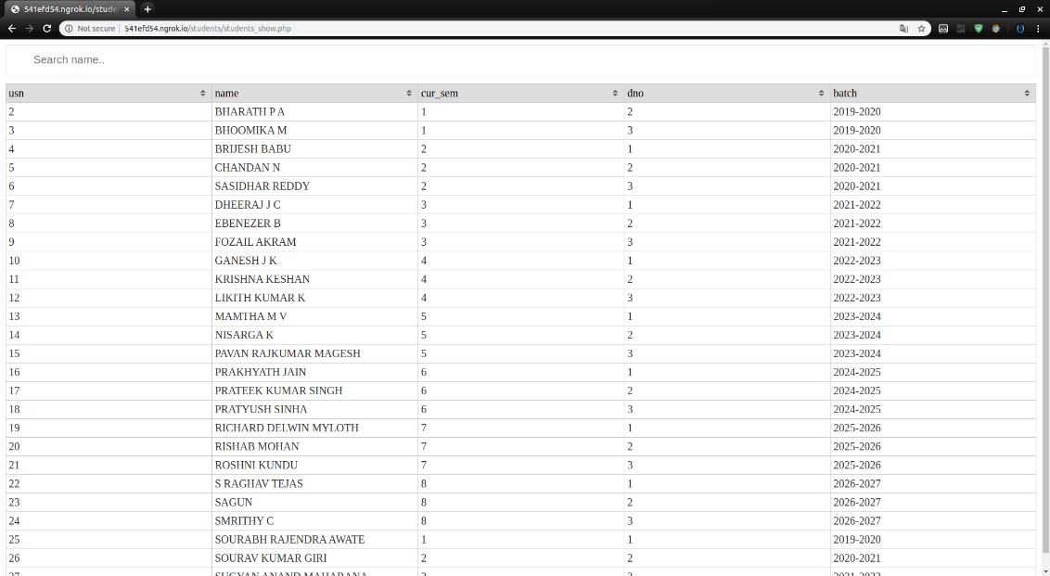

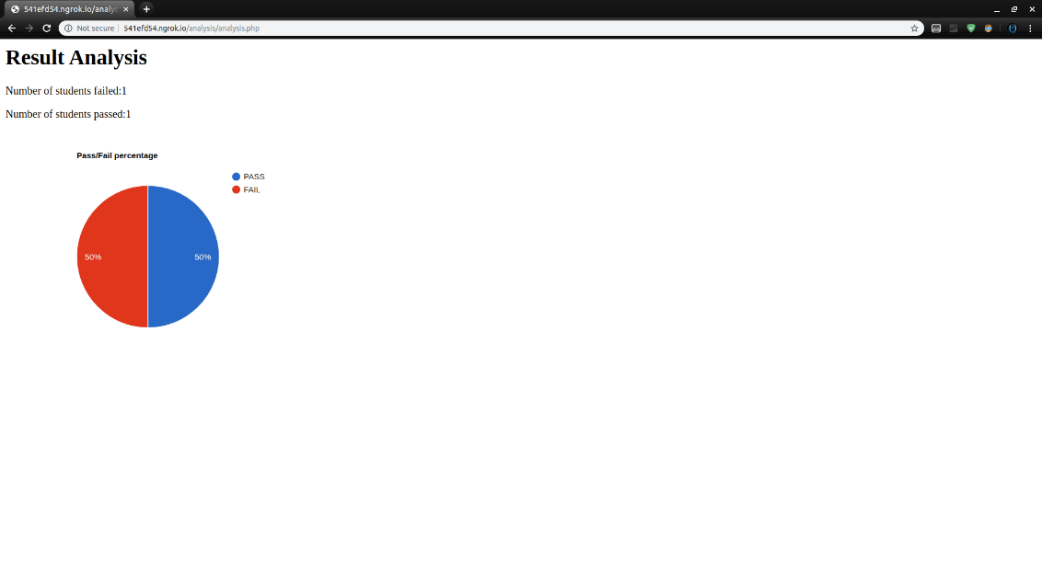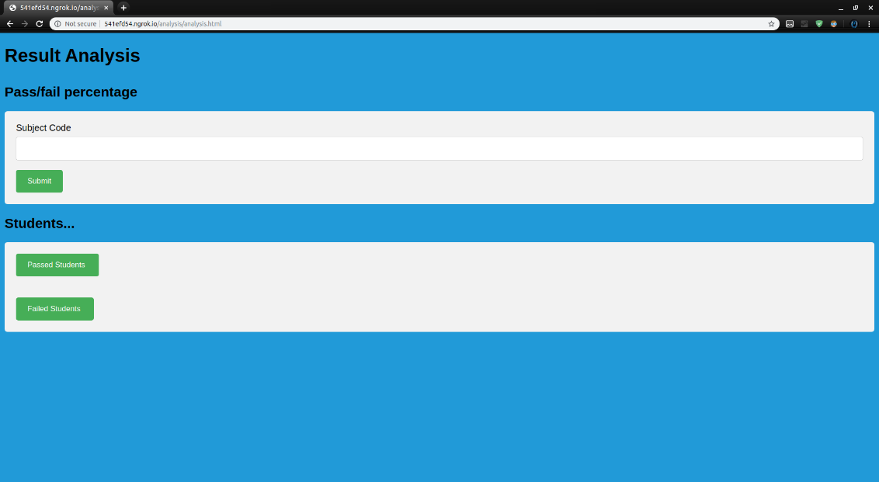

## Chapter 6

**CONCLUSION AND FUTURE SCOPE**

**Section 6.1 Conclusion**

This report has discussed the development of a web application that allows college authorities to see student records belonging to their department, see different result records and the general information of the students under the department. It also allows them to insert a new student record, department record or and marks record to the existing database.

## Section 6.2 Future Scope

The project data and records need to be manually loaded by any user. Future features would include automatically scrapping the results from the VTU results website and creating the database automatically without the need for any manual data entry.

# REFERENCES

1. <https://www.w3schools.com/>
2. <https://www.codecademy.com/learn/learn-css>
3. <https://www.learn-php.org/>